AI BLOGNEST API
TN SKILLS PROJECT



DEPARTMENT OF COMPUTER APPLICATIONS

ALPHA ARTS AND SCIENCE COLLEGE
PORUR, CHENNAI
(Reaccredited by NAAC and Affiliated to University of Madras)

PROJECT TITLE:
AI BLOGNEST API
TEAM ID: SWTID-2026-7026
TEAM MEMBERS:
TEAM LEADER: SRIRAM D
NM ID: B8ED8F79F450F60AE1347C826B6733E5
TEAM MEMBERS:
SELVAGANAPATHY T
NM ID: 814140038E2FB6A827043D058282AC0B
MANIMUTHU N
NM ID: 612D71C5BED3D52B646411511938247E
DINESHKUMAR M
NM ID: 2AAAAE5069FDF5D98DC4BB54B5801243

INTRODUCTION

AI BlogNest API is a backend REST API platform designed for blog creation, content management, and AI-assisted content generation. The system is developed using Node.js and Express.js and uses MongoDB with Mongoose ODM for database management.
The application integrates Google Gemini AI to provide intelligent content-generation and summarization features. It allows users to create and manage blog content while also providing AI-powered assistance for generating and summarizing blog articles.
The system follows a modular backend architecture in which routing, controllers, middleware, services, models, and database configuration are organized separately. This makes the application easier to maintain, test, and extend.
The API also implements authentication and authorization using JSON Web Tokens (JWT). Passwords are securely handled using bcrypt.js, while request validation and security mechanisms help protect the application from invalid or unauthorized requests.

OBJECTIVES
The main objectives of the AI BlogNest API are:
- To provide a centralized backend API for blog management.
- To allow registered users to securely access the application.
- To implement authentication using JWT.
- To provide CRUD operations for blog posts.
- To store blog and user information using MongoDB.
- To integrate Google Gemini AI for automated blog generation.
- To provide AI-powered blog summarization.
- To implement role-based access control.
- To validate and sanitize incoming requests.
10.To provide a modular and scalable backend architecture.
11.To reduce the time required for creating blog content.
12.To provide a secure and reliable REST API for content management.

TARGET USERS
The AI BlogNest API is designed to support different types of users involved in creating, managing, and consuming blog content. The system provides role-based access so that users can perform activities according to their responsibilities.
1. Admin
Administrators have the highest level of access in the system. They can manage users, roles, comments, and other administrative functions.
2. Editor
Editors are responsible for managing and reviewing blog content. They can review posts, handle publishing workflows, and manage categories and editorial activities.
3. Author
Authors use the system to create and manage blog posts associated with their accounts. They can also use the AI-powered content generation functionality to assist in preparing blog content.
4. Reader
Readers primarily access published blog content. They can read available posts and participate through comment-related functionality.
5. Content Creators
The AI-assisted features are useful for users who need to create blog content quickly. The AI blog generation and summarization services can assist them in preparing and refining content.
TECHNOLOGIES USED
- Node.js – Backend runtime environment
- Express.js – REST API development
- MongoDB – Database
- Mongoose – Database modelling
- Google Gemini AI – AI blog generation and summarization
- JWT & bcrypt.js – Authentication and password security
- Postman / Thunder Client – API testing
- Visual Studio Code – Development environment

SYSTEM ARCHITECTURE
- API Client – Sends requests using Postman or Thunder Client.
- Express.js Server – Receives and processes API requests.
- Authentication Middleware – Verifies JWT tokens and user roles.
- Routes – Direct requests to the appropriate controllers.
- Controllers – Handle application logic and API responses.
- Services – Manage specific business operations.
- Mongoose – Connects the application with MongoDB.
- MongoDB – Stores users, blogs, comments, and other data.
- Google Gemini AI – Generates blog content and summaries.

MVC ARCHITECTURE
- Model Layer – Defines the structure of application data using Mongoose schemas and manages data stored in MongoDB.
- View Layer – Since BlogNest is a headless backend API, there is no traditional user interface. The API routing layer acts as the interface for handling requests.
- Controller Layer – Handles incoming requests, processes the required operations, communicates with the models, and sends JSON responses to the client.
- Overall Flow – The request moves from API Route → Controller → Model/Database → Controller → JSON Response.

PROJECT MODULES
- User Authentication Module – Handles user registration, login, authentication, and role-based access.
- Blog Management Module – Provides creation, fetching, updating, and management of blog posts.
- Category & Tag Module – Organizes blogs using categories and tags.
- Comment Management Module – Handles user comments and comment moderation.
- AI Content Module – Generates blog content and summarizes existing content using Google Gemini AI.
- Security Module – Provides JWT authentication, password hashing, validation, and access control.

DATABASE DESIGN
The system uses MongoDB as the database with Mongoose for data modelling.
- User Collection – Stores user ID, name, email, password, and role.
- Post Collection – Stores post ID, user ID, title, content, photo, likes, and timestamps.
- Comment Collection – Stores comments associated with users and blog posts.
- Relationships – A user can create multiple posts and comments, while a post can contain multiple comments.

API TESTING OUTPUT
The AI BlogNest API was tested using Thunder Client to verify the functionality of the major API endpoints. The following operations were successfully tested:
- User Registration – New user registration was completed successfully.
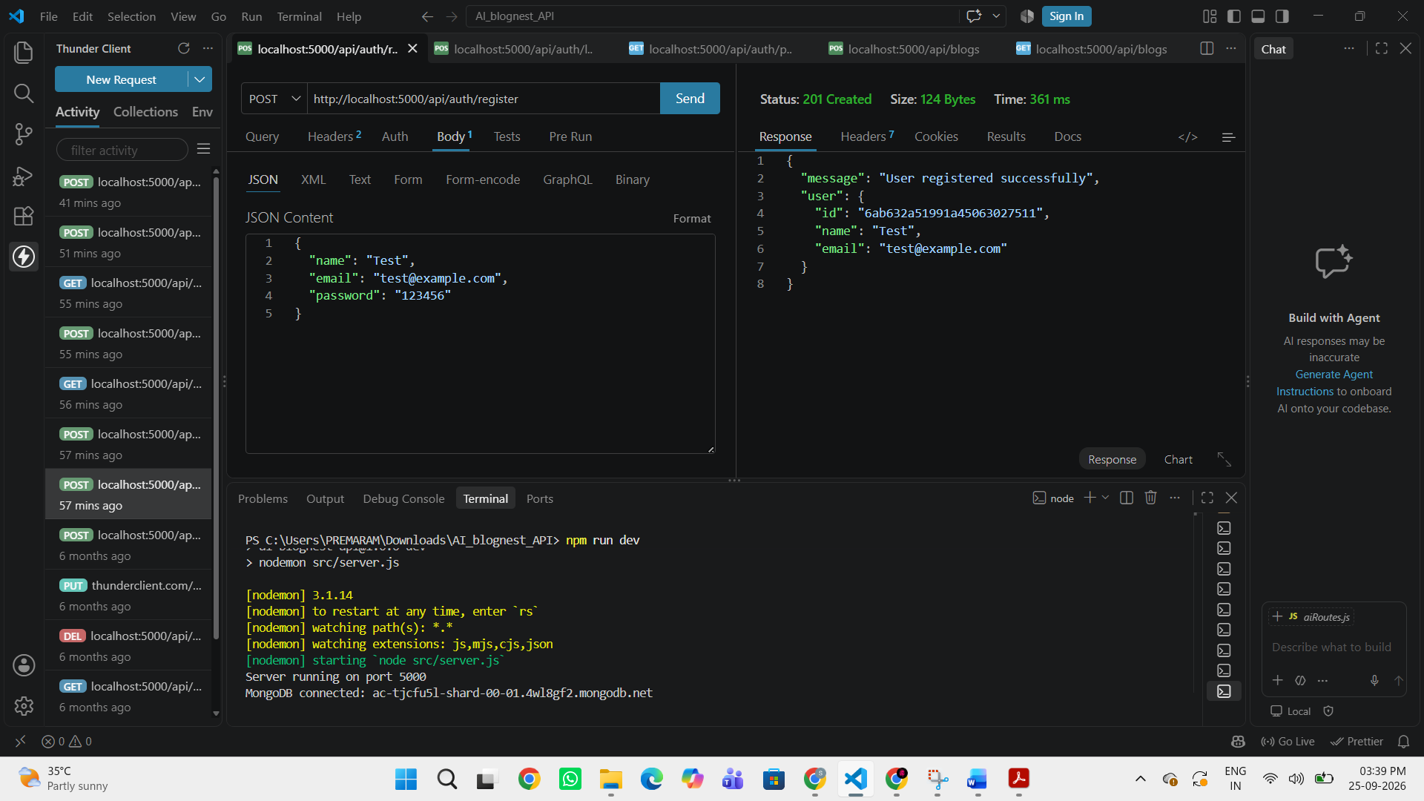
- User Login – User authentication was completed successfully.
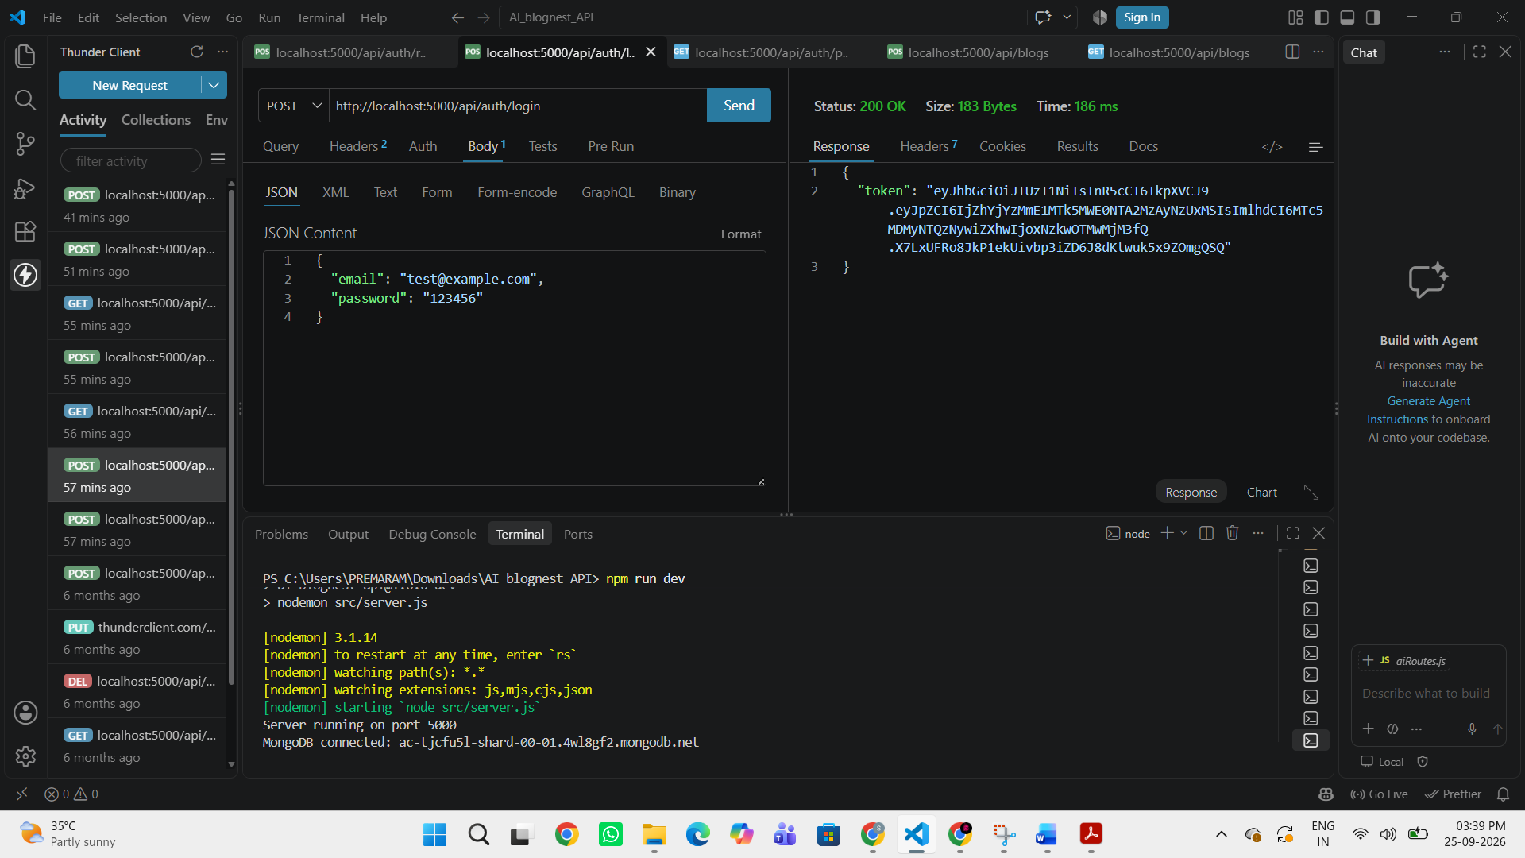
- Create Blog – A new blog was created successfully.
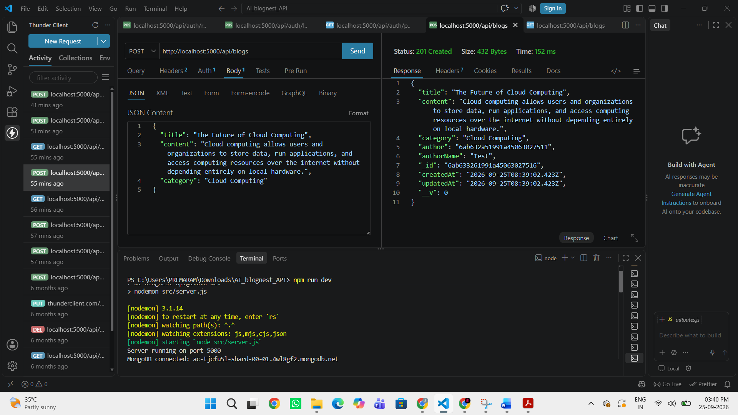
- Fetch Blogs – Existing blogs were retrieved successfully.
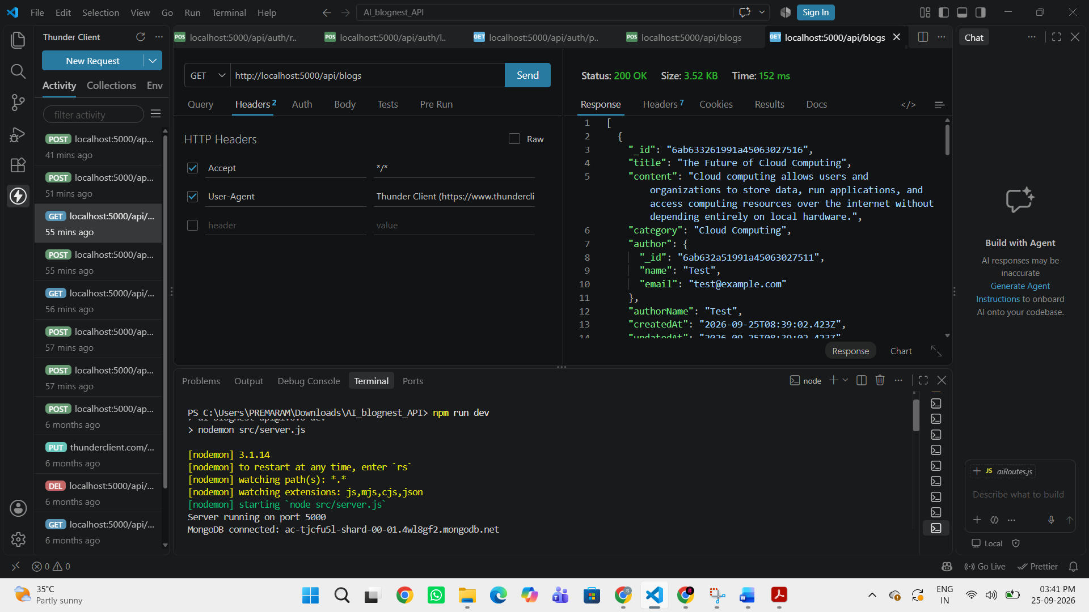
- Generate AI Blog – AI-generated blog content was created successfully.
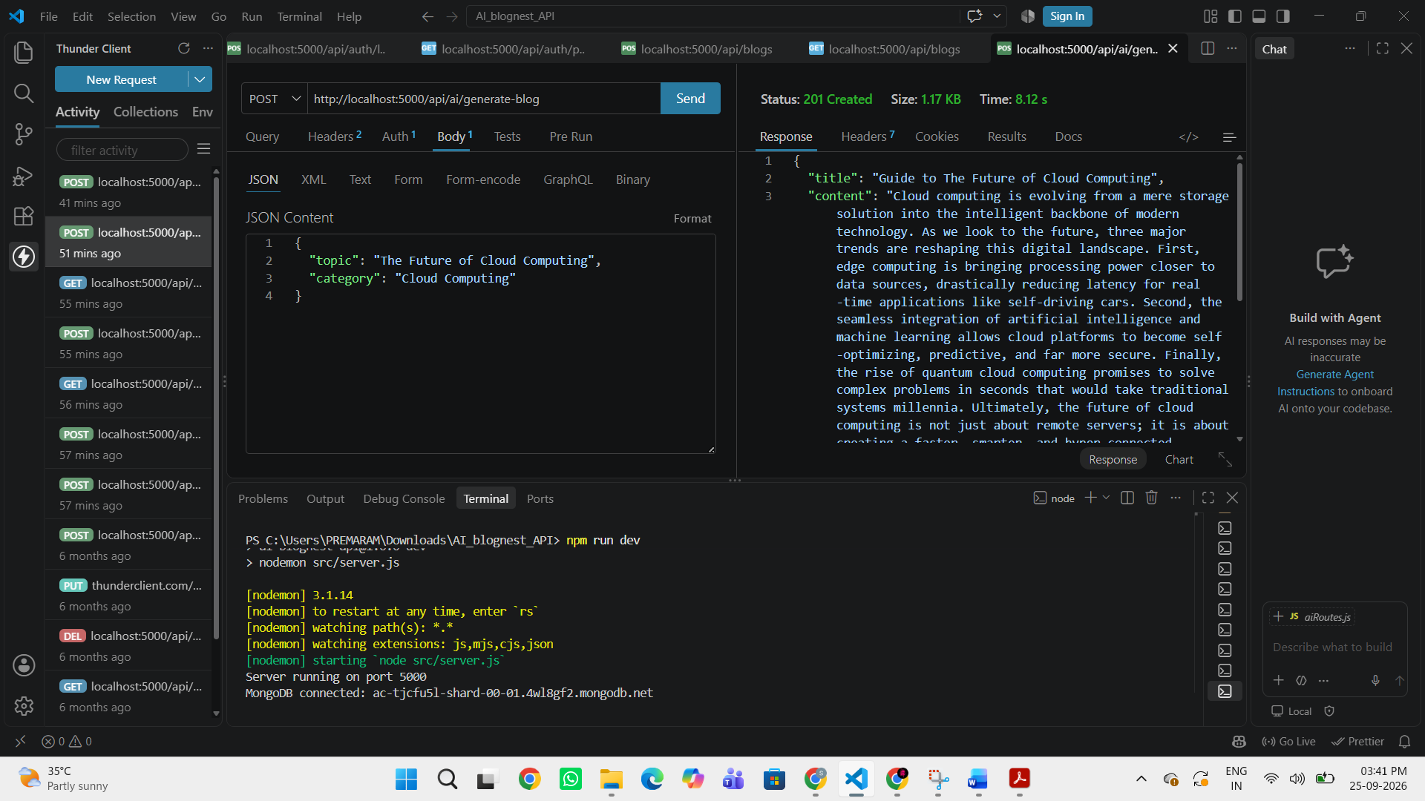
- Summarize Blog – Blog content was summarized successfully.
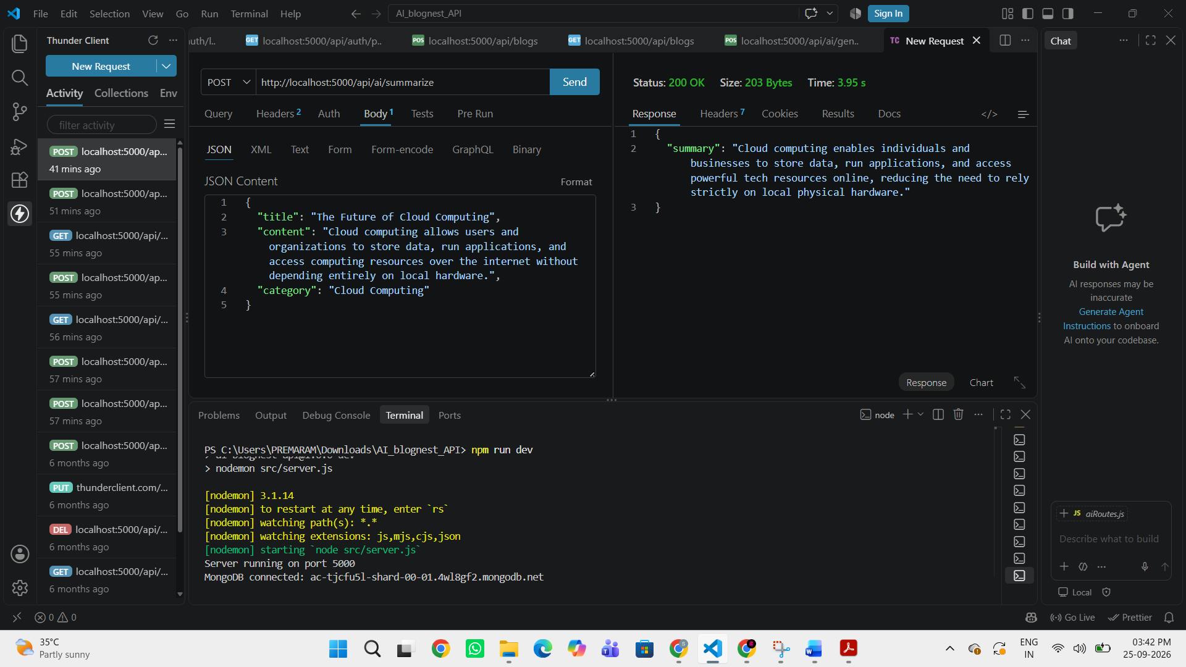

CONCLUSION
The AI BlogNest API successfully provides a secure and efficient backend platform for creating, managing, and processing blog content. The system uses Node.js and Express.js for backend development, MongoDB and Mongoose for data storage and management, and Google Gemini AI for AI-based blog generation and content summarization.
The project also implements JWT-based authentication and role-based access control to provide secure access to different users. The major API functionalities, including user registration, login, blog creation, blog retrieval, AI blog generation, and summarization, were successfully tested using API testing tools.
Overall, the project demonstrates the integration of REST API technology, database management, authentication, and Generative AI to create a modern and scalable content management system.

GITHUB LINK:
https://github.com/sriramaasif-lab/AI-Blog-NEST
DEMO VIDEO LINK:
Shttps://drive.google.com/file/d/1LVPIsI6K4WsKPReIUuqu7632IjQ1cdXP/view

